**Artificial Intelligence Vs. Machine Learning Vs. Deep Learning Vs. Data Science**

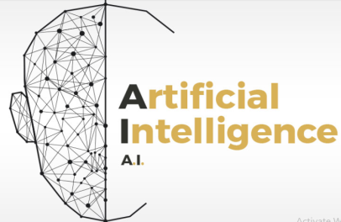 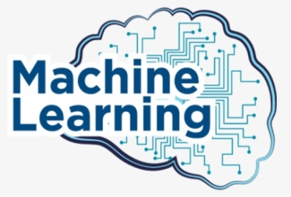 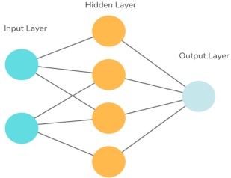

A.I Machine Learning Deep Learning

**Venn diagram A.I Vs. ML Vs. DL**

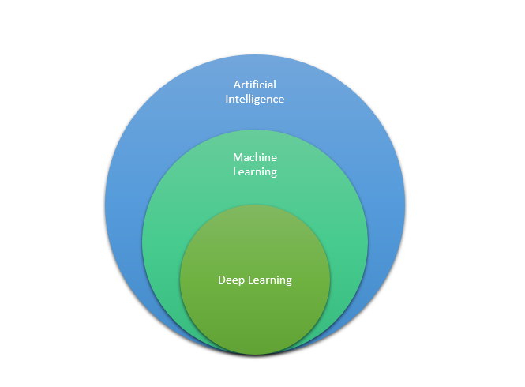

Deep Learning is a subset of Machine Learning.

Machine Learning is a subset of Artificial Intelligence

**What is Artificial Intelligence?**

Artificial Intelligence is a branch of computer science that is concerned with building smart & intelligent machines.

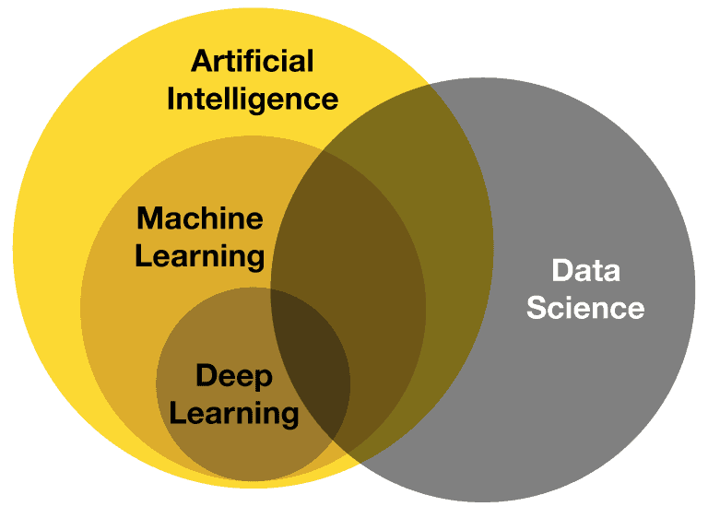

* Artificial Intelligence helps us to enable the machine to think without any human intervention.
* Machine will be able to take its own decision.

**What is Machine Learning?**

Machine Learning is a technique to implement A.I. that can learn from the data by themselves without being explicitly programmed.

* Machine Learning is a subset of A.I.

**What is Deep Learning ?**

Deep Learning is a subfield of ML that uses special type of algorithms called as artificial neural networks to learn from the data.

